CHAPTER 1

INTRODUCTION

  - ORGANIZATION PROFILE

The SSN Institutions was born out of Mr. Shiva Nadar’s ardent desire to give back to the society that nurtured him. The institution reflects the ideals of the founder and seeks to achieve excellence in emerging technologies education.
In pursuance of the spirit of the trust, the Institution was started in 1996, with the approval of AICTE, and affiliated to the University of Madras. Commencing from the batch of students admitted during 2001-02, the Institution is affiliated to Anna University, the premier Technological University of Tamil Nadu. The Institution is ideally located on a sprawling 250 acres campus on the Rajiv Gandhi Salai – known as the ‘Cyber Corrider’ of the Chennai. The Institution has established a vast range of infrastructure for learning, such as the state-of-the-art computer centers, modern workshops, labs, seminar hall, auditoriums and well equipped libraries, in addition to indoor stadium.

The Institution’s communication network links all part of the campus and comprises computers of the latest configuration for use by staff and students. SSN Institutions have launched an e-learning initiative for UG and PG programs from current academic and the campus is Wi-Fi enabled.

  - OBJECTIVE

To develop an alumni network management which provides all kinds of access and control over the information and details from/to alumni, who are part of the institution and provide other services like discussion forum for interaction between students and alumni, job portal for alumni to post or view jobs, alumni chapters, newsletters from alumni officer.

  - FEASIBILITY STUDY

Feasibility is the measure of how beneficial the development of alumni network management system would be to an organization. The project with sufficient planning and effort can be completed in six months with an additional one month for migration. The project proposed is going to be developed using ASP.NET 4.0 with MySQL 6.4.3 as a back end on a windows environment. The project needs to be developed in a team containing 2 developers, both as designers, a testing team, headed by an alumni team leader and a mentor.

1.3.1 Schedule feasibility:

During schedule feasibility study, it was found that the system operates in the way that user wants. There are enough human resources and there are qualified and experienced manpower available for the development and implementation of the system. The new system is acceptable to the alumni people and management.

1.3.2 RESOURCE feasibility:

Resource feasibility is the most important study that determines the cost and benefits of the proposed system and compares with the budget. The cost of the new system does not outweigh the budget. The cost of the project includes the cost of hardware, software, development and implementation. The new system also provides benefits that are expected from the proposed system and compare these with costs expected to spend on development of the system. Benefits are found to be more than costs, thus it is decided to develop new system. The new system provides both tangible and intangible benefits in a formal way. Thus the new system is resourcefully feasible.

1.3.3 TECHNICAL / IMPLEMENTATION feasibility:

It was found that the new system is both Scheduled and resourcefully feasible, the next step is to be determine whether it is technically feasible or not. During this study, it was found that the organization has enough resources to implement the new system. There already exists a computer system with suitable hardware and software in the concerned organization.

Technical feasibility includes 2 main aspects:

    - Hardware feasibility
    - Software feasibility

Hardware feasibility:

To implement this project we need different types of hardware configuration for server and client such as,

- Processor : Pentium 4 or higher / AMD
- RAM : 1 GB
- Hard Disk space : 40GB

Software feasibility:

This system is developed using ASP.NET 4.0. All the resources used for the development of the project are available. The system can be expanded as required in future and modified with the change of acts and rules. Accuracy, reliability, ease of access and security of the system is maximum. The tools to be used are highly reliable, updated and efficient. Thus the proposed system is technically feasible.

CHAPTER 2

SYSTEM ANALYSIS

  - PROPOSED SYSTEM

The scope of the project is to provide the one click access to the student’s forum, job portal, and news letter, chapters, alumni activities, achievements, galleries and more. This helps alumni will re-engage themselves with the institution.

The Alumni website helps alumni officer establishes a “two-way street” to communicate directly with each alumnus, following their specific interests. By tracking how the interests of the alumni evolve through this site, we can then adapt the alumni communications accordingly.

  - PROJECT MODULARIZATION

The System is divided into 3 major modules, they are as follows,

- Alumni Network Module.
- News Letter Module.
- Chapters.

2.2.1 Alumni Network Module

The alumni network module computerizes all the activities related to the alumni and student interactions. Alumni network module involves two processes. The first process would be the job portal. It manages the post job and view job. The second process would be the discussion forum where alumni and students interact by posting queries and view replies for the queries posted.

2.2.1.1 Job Portal

Job Portal module comprises of two main steps, the first step is posting of company information and the second step is posting of job requirement. This module also consists of two actions namely Post job and View job which can be accessed by alumni to either post a job or view a job to apply for.

2.2.1.2 Forum

Forum module comprise of creating a new topic for interaction between student and alumni or between alumni itself. Only those user who have logged in can view or reply to the forum topics. Those who have not logged in they can only view the forum topics available. The posted topics will be listed out on entering the forum page and on selecting the particular topic from the list we can reply to it and also view other replies for that topic posted by either student or the alumni.

2.2.2 News Letter Module

This module is accessed by alumni officer to send mails along with the attachments to alumni through this site to let them know about the recent happenings in the college, such as the appointment of high-level administrators or trustees, remarkable sports victories, grand events at the institution, and the launch of a social campaign.

2.2.3 Chapters

This module can be accessed by two types of users. One of them is alumni officer who can accept or reject the proposal of new alumni chapter to be started by alumni in their resident location. The other user is alumni who can request the alumni officer to start a new chapter in their resident location by providing all the necessary details as sent by the alumni officer through mail. For alumni to start a new chapter the alumni has to follow the rules and guidelines as posted by the alumni officer in this site.

CHAPTER 3

SYSTEM DESIGN

3.1 System Architecture

3-tier application is a program which is organized into three major disjunctive tiers on layers. These layers are Application layer, Business layer and the Data layer. Application layer is the form which provides the user interface to either programmer of end user. Programmer uses this layer for designing purpose and to get or set the data back and forth. . Business layer is a class which we use to write the function which works as a mediator to transfer the data from Application or presentation layer data layer. Data Layer is also a class which we use to get or set the data to the database back and forth. This layer only interacts with the database. The database queries or uses stored procedures to access the data from the database or to perform any operation to the database. The user requests are being sent to the Sliver Light server as ASPX pages. These requests are processed by ASP Engine and sent to the database as queries. MySQL is the database which processes the query and response to the ASP Engine.

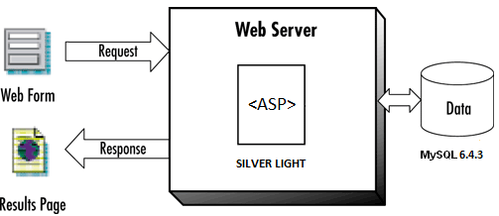

Figure 3.1 System Architecture

3.2 Data Flow Diagrams

Data flow diagrams are used to describe how the system transforms information within the system. They define how information is processed and stored and identify how the information flows through the processes within this system. The data flow diagram illustrates the processes, data stores, and external entities associated with this system.

3.2.1 Context Level Diagram

The context diagram at the project level is the root of the functional decomposition at the conceptual level of detail. The context diagram focuses on relationships with external entities and identifies the information that is exchanged between these external entities and the business system under review. The external entities

They are outside the scope of the project but the data flows between the entities and the business system are within the project scope.

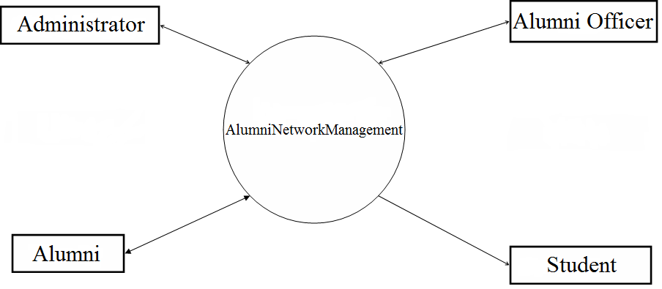

Figure 3.2 Context Level Diagram

3.2.2 Data Flow Diagram Level - 1

The DFD mainly has four processes, which are job portal, forum, news letter, and chapters. These processes access the alumni network management database for getting authentication and for storing/retrieving the details of alumni and also sending/receiving mails.

The DFD for the job portal module consists of information with respect to company details and job details provided as input data from the alumni and on completing the details the data flows through the server i.e. silver light and stored in the database. The DFD for the Forum module consists of data flow from and to the database with the help of the server first it gets the input data in the form of forum topic name, detail of the post, name of the user posted and email id of the user posted from the alumni or student and on
completing the details the data flows through the server and stored in the database then data flows from the database to the forum list page through the server and is displayed in the page and upon alumni or student updating the forum post reply the data flows from the page to the database through the same server and gets updated in the database. The DFD for the newsletter module consists of input data in the form of mail-id and message from alumni officer which is then sent to the server for verification process and later email is sent to those set alumni group members who’s mail-id are specified as input. The DFD for the chapter’s module consists of country request message and email id of the user requesting the chapter page to the alumni officer.

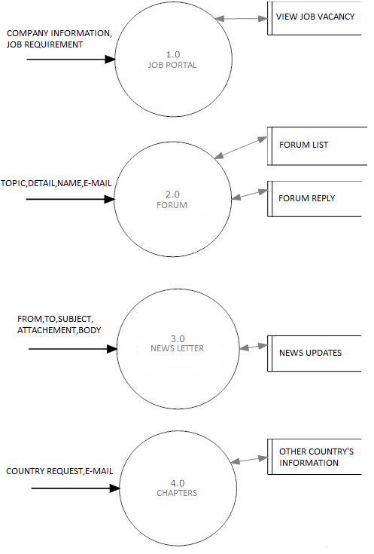
Figure 3.3 Data Flow Diagram Level - 1
3.3 Use Case Diagram

The following use case diagram consists of actor namely alumni can access alumni network which includes job portal and forum for to post or view or reply and can access newsletter and chapters for to view.

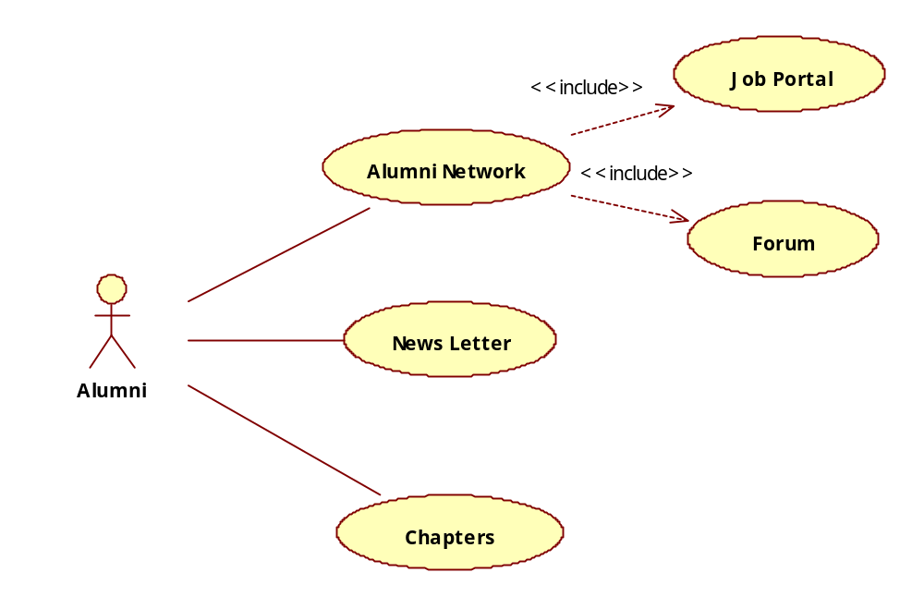

Figure 3.4 Use Case Diagram - Alumni Level

The following use case diagram consists of actor namely students who can access the alumni network for to view job portal and for to add or view or update the forum post.

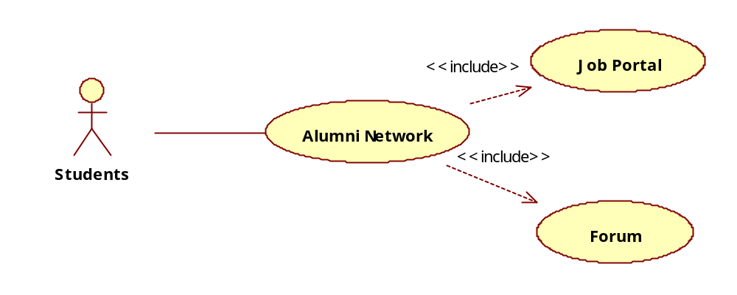

Figure 3.5 Use Case Diagram - Students Level

The following use case diagram consists of actor namely alumni officer who can access for to add or update or delete the newsletter and chapters.

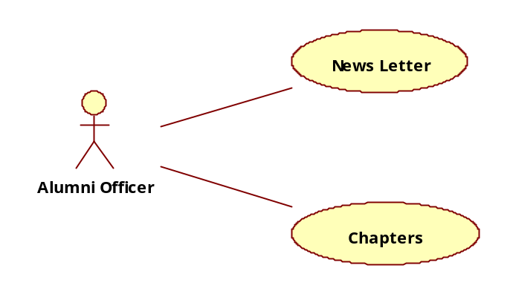

Figure 3.6 Use Case Diagrams – Alumni Officer Level

3.4 TABLE DESIGN

MySQL 6.4.3 is used for storing data pertaining to this application. Totally four tables are used based on the requirements.

3.4.1 JOB POST

The job post table stores basic information about the company information and job profile requirement.

FIELD NAME | DATA TYPE | DESCRIPTION | CONSTRAINT
rowid | INTEGER | Job ID | PRIMARY
postdate | VARCHAR(50) | Date of job post | NULL
contperson | VARCHAR(50) | Person to be contacted | NULL
desig | VARCHAR(100) | Designation of the contact person | NULL
cmpname | VARCHAR(50) | Name of the company | NULL
contaddr | VARCHAR(100) | Address of d company | NULL
country | CHAR(50) | Location of d company | NULL
zipcode | VARCHAR(50) | Company postal code | NULL
number | VARCHAR(20) | Company contact number | NULL
email | VARCHAR(50) | Company’s email-id | NULL
website | VARCHAR(50) | Company website | NULL
desigoffer | CHAR(50) | Designation offered | NULL
qualify | CHAR(25) | Qualification | NULL
expyrs | VARCHAR(10) | Years of experience | NULL
location | CHAR(40) | Location of job | NULL
jobprof | CHAR(200) | Job profile | NULL
incr | VARCHAR(20) | Salary increment | NULL`
emptype | CHAR(20) | Job type | NULL
filepath | VARCHAR(100) | Location of attachment | NOT NULL

Table 3.1 Table – Job Post

3.4.2 FORUM_QUESTION

The Forum_question table stores basic information about the newly generated topics and it contains all the details about the topic posted.

FIELD NAME | DATA TYPE | DESCRIPTION | CONSTRAINT
rowid | INTEGER | Forum topic ID | PRIMARY
topic | VARCHAR(50) | Forum topic | NULL
detail | LONGTEXT | Forum Detail | NULL
name | VARCHAR(50) | User name | NULL
email | VARCHAR(50) | User name’s email-id | NULL
datetime | VARCHAR(30) | Date of the forum topic posted | NULL
views | VARCHAR(50) | No of times forum topic visited | NULL
reply | LONGTEXT | No of replies for the forum topic | NULL

Table 3.2 Table – Forum_question

3.4.3 FORUM_ANSWER

The Forum_answer table stores basic information regarding the answer details that pertains to a particular question posted.

FIELD NAME | DATA TYPE | DESCRIPTION | CONSTRAINT
quest_id | INTEGER | Forum topic ID | PRIMARY
ansid | INTEGER | Id of the answer for a particular topic | NULL
ansname | VARCHAR(50) | Name of the user who replied to the topic | NULL
ansemail | VARCHAR(50) | Email-id of the person who replied | NULL
answer | LONGTEXT | Answer for the particular topic | NULL
ansdatetime | VARCHAR(30) | Reply date and time | NULL

Table 3.3 Table – Forum_answer

CHAPTER 4

SYSTEM REQUIREMENTS

  - HARDWARE REQUIREMENTS

    - Client and Server Hardware Requirement

- Processor : Pentium 4 or higher / AMD
- RAM : 1 GB
- Hard Disk space : 40GB

  - SOFTWARE REQUIREMENTS
4.2.1 Client Software Requirement

- GUI Operating System
- Browser Google Chrome

    - Server Software Requirement

- Operating System : Windows XP or above
- Front End : ASP.NET 4.0
- Back End : MySQL 6.4

CHAPTER 5

SYSTEM TESTING

  - TESTING OBJECTIVES

The objectives for the testing have to be set keeping in mind the scope of the “Alumni Network Management”. The objectives are:
- The input values have to be validated for the variable type and size specified in the database
- Secured pages should be accessed only through session
- Logical sequence in navigation has to be maintained.

  - TESTING METHODLOGIES

The test cases are made to check and execute all the functionalities of “Alumni Network Management”. The following are the tests conducted for this System.

    - UNIT TESTING

Each unit of the System implemented in the source code checked for correctness. All error-handling paths are tested.

    - FUNCTIONAL TESTING

All the modules in the System are checked for its functionality using a set of test cases and verified manually by executing the system using test data.

    - INTEGRATION TESTING

The Integration Test has been done which focuses on the screen mapping and integration of data values between modules of “Student Management System”.

    - PERFORMANCE TESTING

Load Testing is conducted to evaluate maximum number of users supported by the server machine.

    - SYSTEM TESTING

Finally System testing is conducted to evaluate the system’s compliance with its specified requirements.

  - TEST CASES

The test case validations are worked out before the test is executed. Each validation has a known input and an expected output. The known input should test a precondition and the expected output should test a post condition. The sample validations for test cases are given bellows:

    - Job Portal Module – Test Cases

Table 5.1 Test Cases – Job Portal

Test Case Id | Test Condition | Test Input | Expected Result | Actual Result | Test Result
ANM-JPM-JP-01 | Textboxes should not be empty | Empty or wild char input | Error message should be displayed | Error message is displayed | Pass
ANM-JPM-JP-02 | The user should select data in appropriate drop-down list box | Non selection is made | Error message should be displayed | Error message is displayed | Pass
ANM-JPM-JP-03 | Documents or files can be uploaded | Non documents or files are uploaded | Error message should be displayed | Error message is displayed | Pass
ANM-JPM-JP-04 | User details must be inserted in appropriate table | The details are entered | The details should be inserted in the appropriate table | Details stored in appropriate table | Pass

5.3.2 Forum Module – Test Cases

Table 5.2 Test Cases – Forum

Test Case Id | Test Condition | Test Input | Expected Result | Actual Result | Test Result
ANM-FM-F-01 | Textboxes should not be empty for to create new forum topic | Empty or wild char input | Error message should be displayed | Error message is displayed | Pass
ANM-FM-F-02 | The user should click the posted forum topic list for to view and reply | Click is made on a particular forum topic | Forum reply page should be opened and reply mode should be activated | Forum reply page is opened with reply mode activation | Pass
ANM-FM-F-03 | The question and answer which are entered should be inserted in the appropriate table | The details are entered | The details should be inserted in the appropriate table | The details are inserted in the appropriate table | Pass

5.3.3 News Letter Module – Test Cases

Table 5.3 Test Cases – News Letter

Test Case Id | Test Condition | Test Input | Expected Result | Actual Result | Test Result
ANM-NLM-NL-01 | Textboxes should not be empty for to send new mail | Empty or wild char input | Error message should be displayed | Error message is displayed | Pass
ANM-NLM-NL-02 | The user should click the send mail button for to send news letter | Click is made on a send mail button | Mail should reach appropriate receivers and sent message should be displayed | Mail is reached appropriate receiver and sent message is displayed | Pass

5.3.4 Chapters Module – Test Cases

Table 5.4 Test Cases – Chapters

Test Case Id | Test Condition | Test Input | Expected Result | Actual Result | Test Result
ANM-CM-C-01 | The user should click the chapters menu for to view any countries chapter | Click is made on the chapters menu | Selected countries chapter page should be opened | Selected countries chapter page is opened | Pass

CHAPTER 6

SYSTEM IMPLEMENTATION

The developed “Alumni Network Management” has been deployed in a new server which is only dedicated for Alumni Network Management. Hence all the ASP pages are implemented in this server. These pages are running in Silver Light version 6 which has been installed in the new server. The computer systems which have been accessed to this server can access this tool.

This phase deals with issues of quality, performance, baseline and debugging. The end deliverable is the product itself. There are three types of implementation:

- Implementation of a computer system to replace a manual system
- Implementation of new computer system to replace an existing one
- Implementation of a modified application to replace an existing one, using the same computer

Implementation of “Alumni Network Management” comes under the second category. At the end of the specified period, the system performance and the reliability are tested. Implementation is the key stage in achieving a successful new system because it involves a lot of upheaval in the user department. So, it must be carefully planned and controlled. The newly developed computer system is made operational only when the computer satisfies the user requirements

CHAPTER 7

CONCLUSION

  - CONCLUSION

The project “ALUMNI NETWORK MANAGEMENT” has been developed as per the requirement specification. It has been developed in ASP.NET 4.0 and MYSQL 6.4.3, the complete system is thoroughly tested with the availability of data. This design is so flexible that any new modules can be incorporated easily.

The “Alumni Network Management” will help the organization as well alumni association in keeping track of alumni interactions with the institution. It also allows the alumni officer to communicate directly with each alumnus, following their specific interests. This system is user friendly and it has almost all the facilities which the alumni association would like to have.

  - LIMITATIONS

- This system is limited to work on a set of browsers.

  - FUTURE ENHANCEMENTS

- System can be updated in such a way that it can work on all browser.
- The complaints of the user are not handled.
- The portal can be extended for a larger user base beyond the Indian users.
APPENDIX 1

SCREENSHOTS

A 1.1

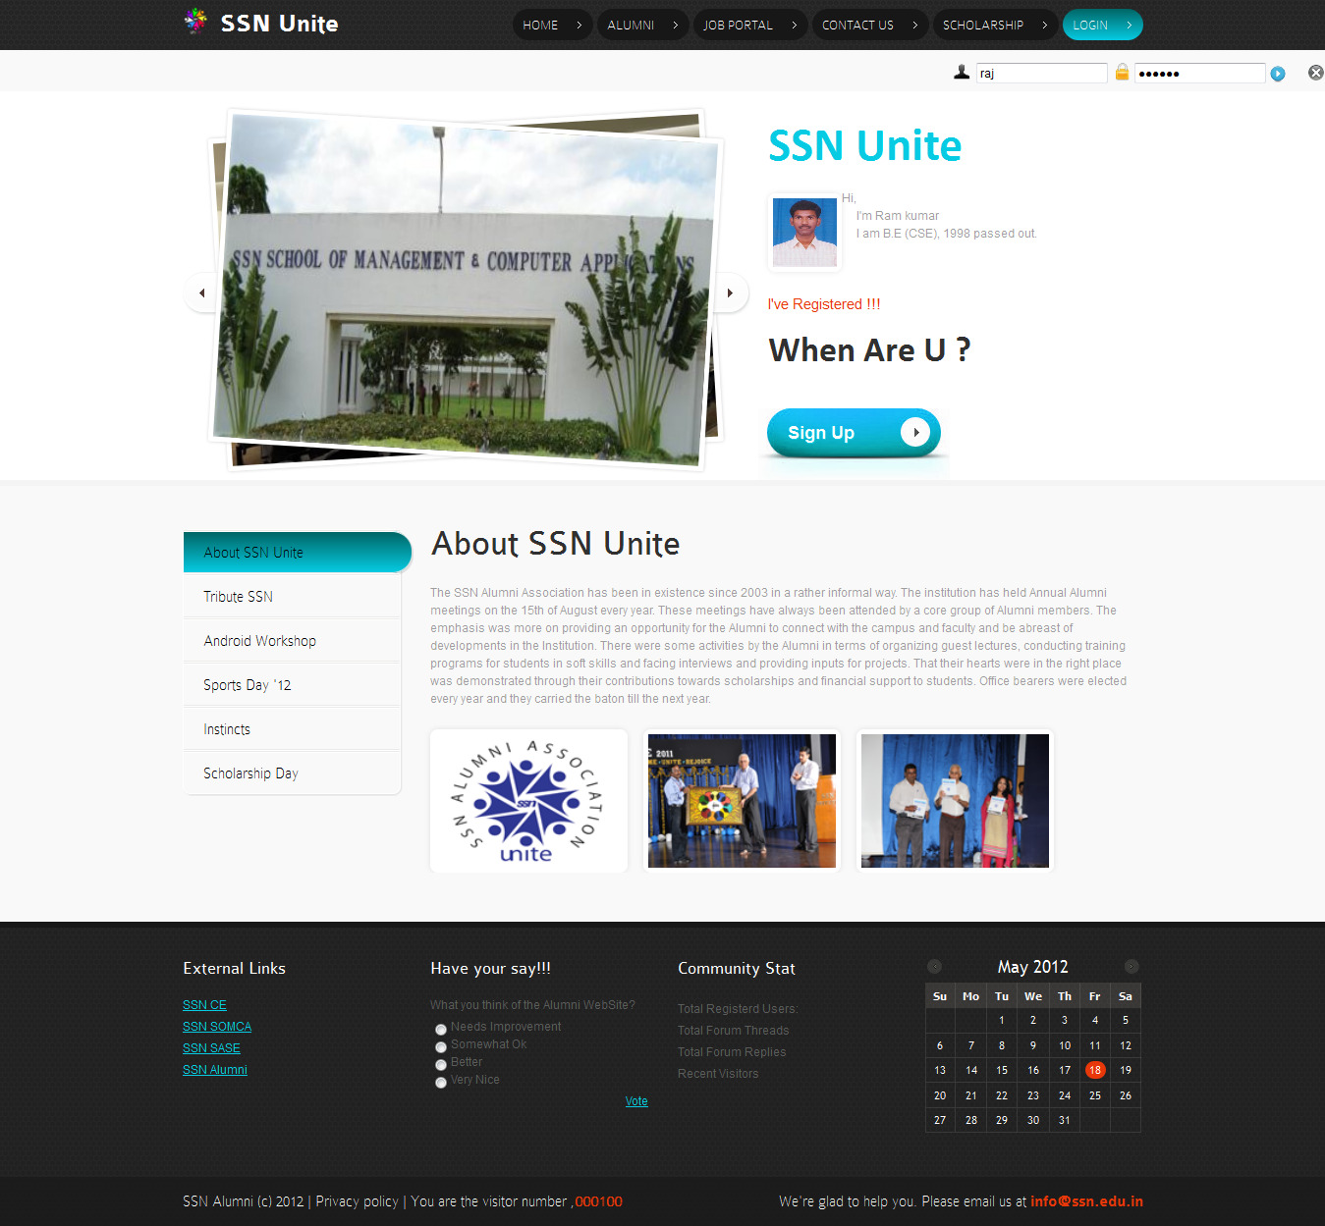

Figure A 1.1 Index Page
A 1.2

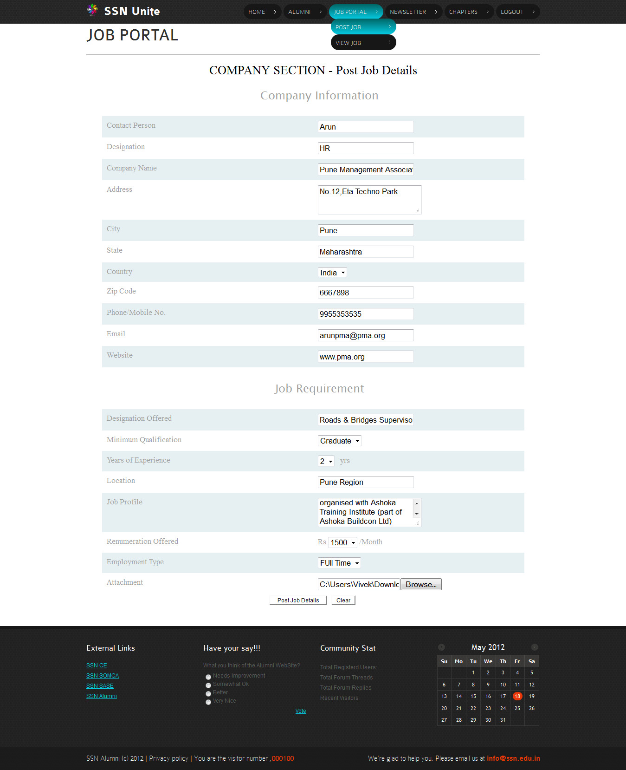

Figure A 1.2 Post Job Page
A 1.3

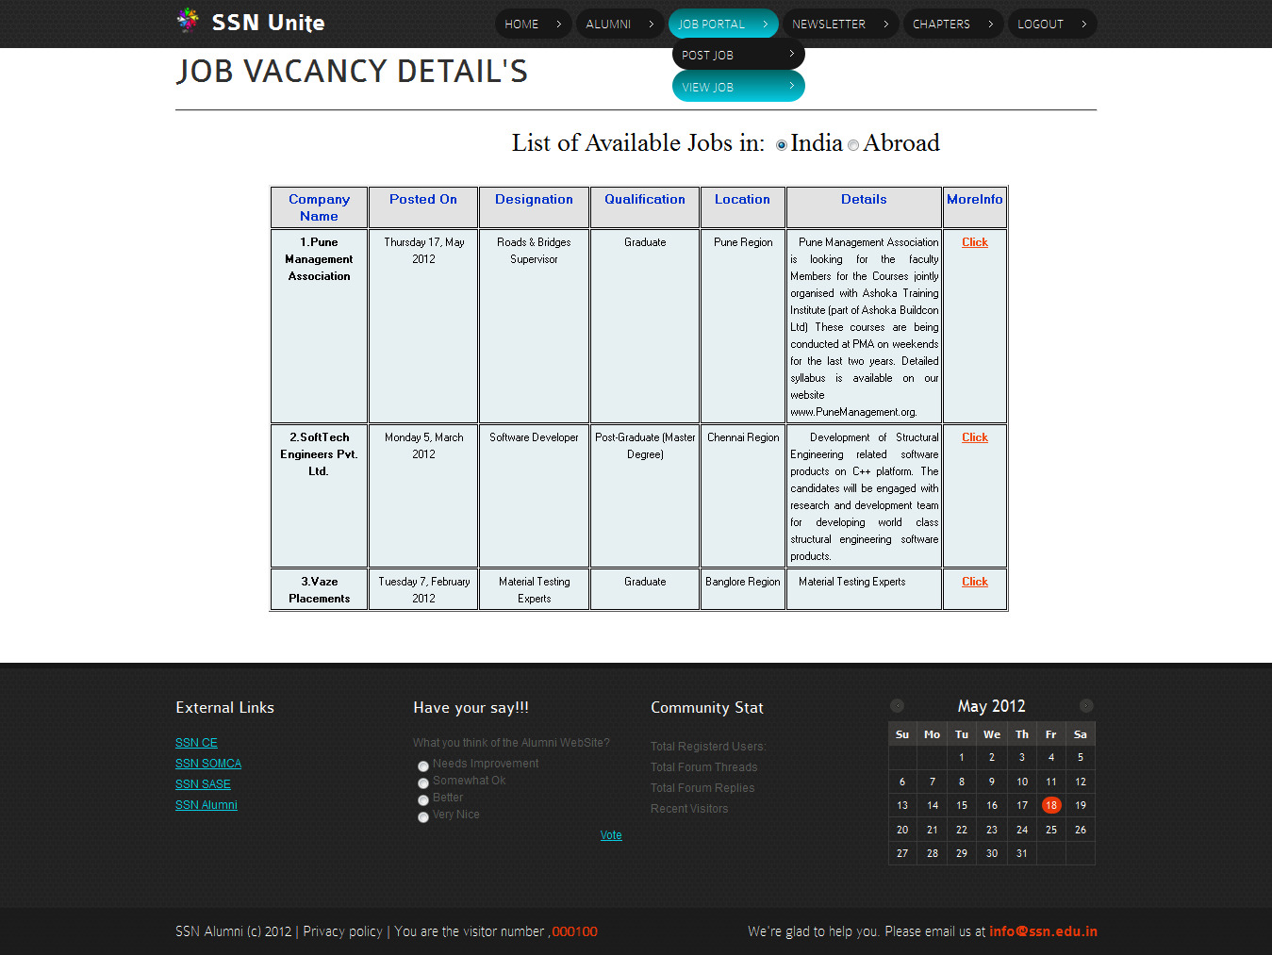

Figure A 1.3 View Job Page

A 1.4

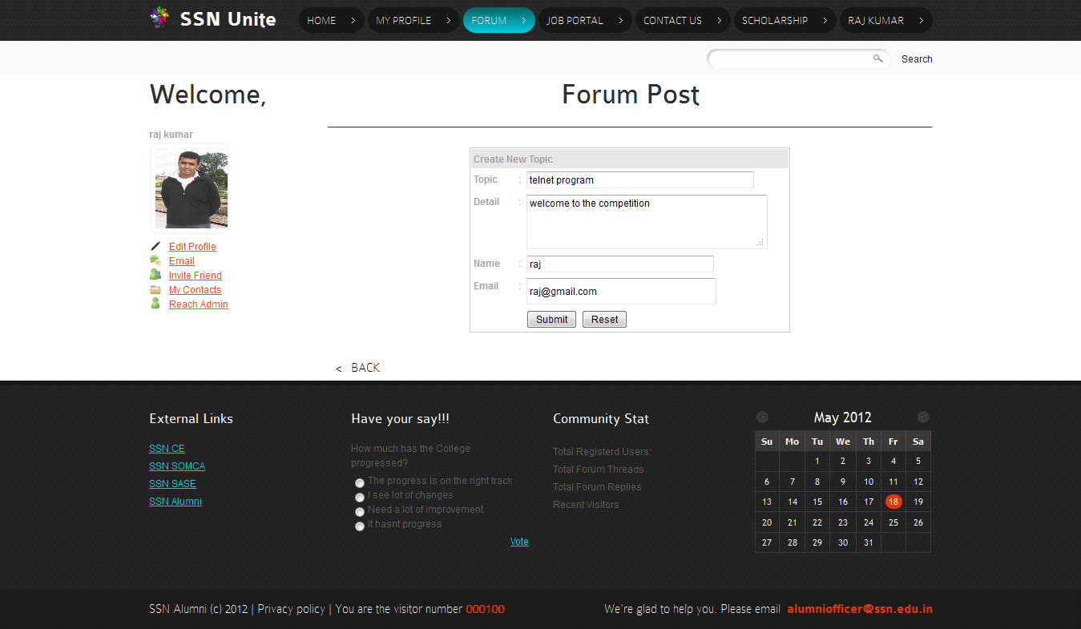

Figure A 1.4 Forum Post Page

A 1.5

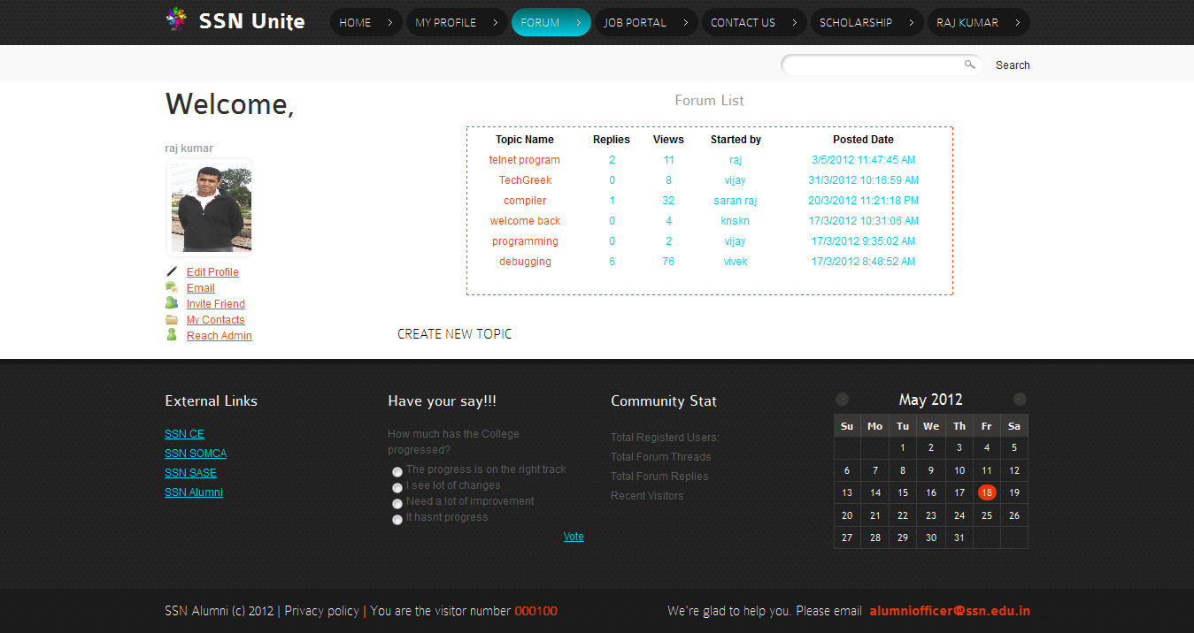

Figure A 1.5 Forum List Page

A 1.6

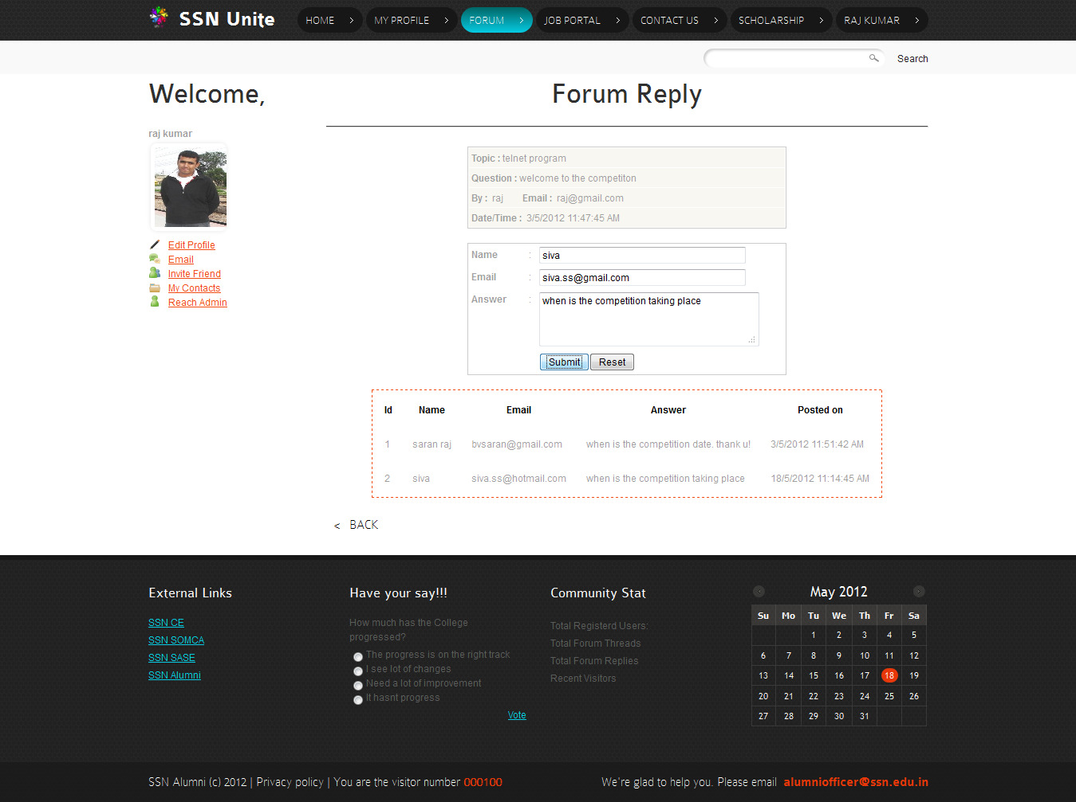

Figure A 1.6 Forum Reply Page

A 1.7

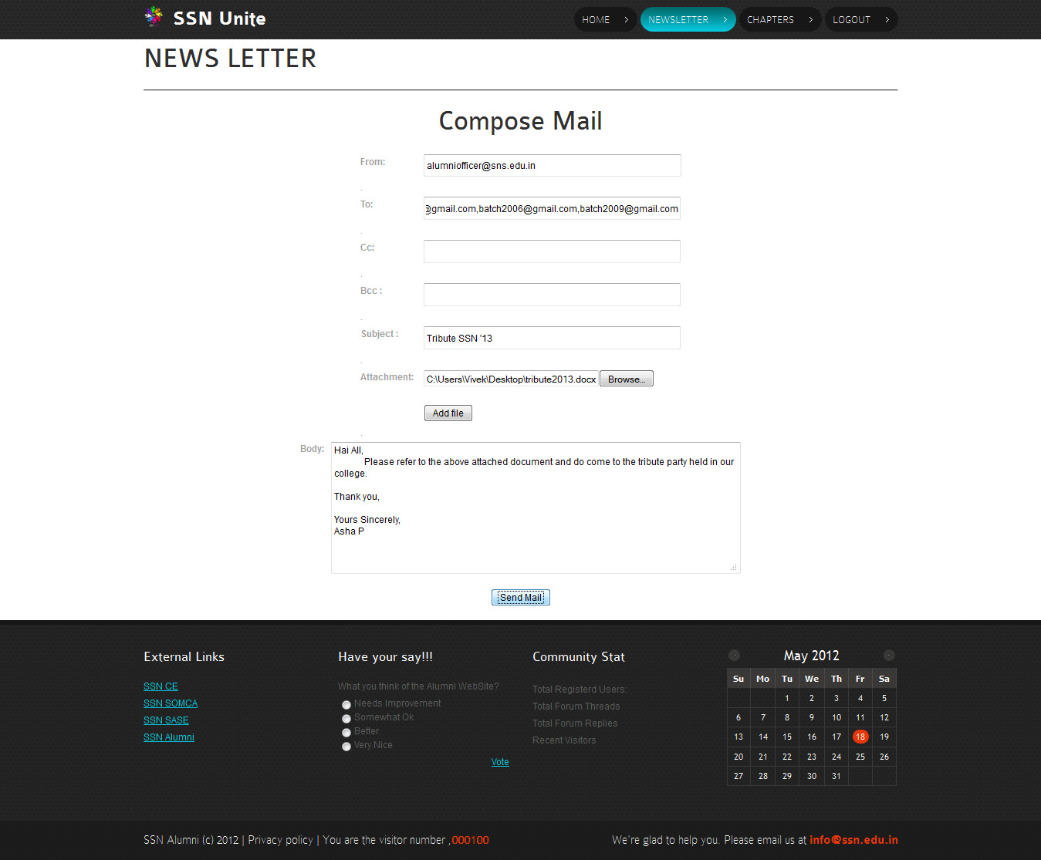

Figure A 1.5 News Letter Composing Page

A 1.8

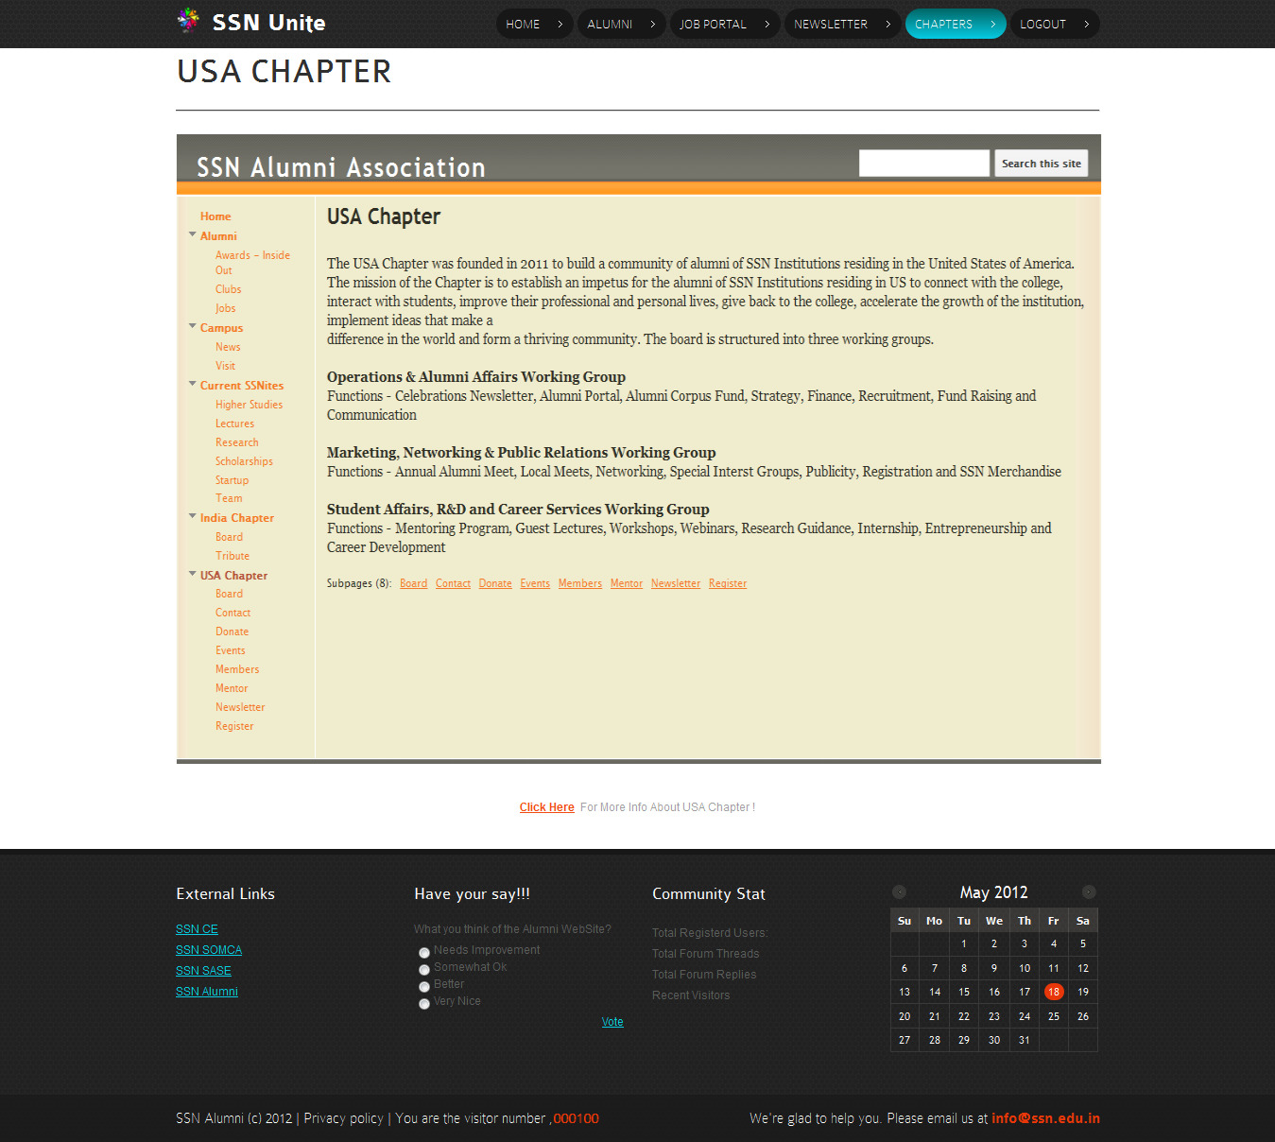

Figure A 1.8 Chapters Page

APPENDIX 2

SOFTWARE DESCRIPTION

A 2.1 ASP.NET

ASP.NET is a Web application framework developed and marketed by Microsoft to allow programmers to build dynamic Web sites, Web applications and Web services. ASP.NET is built on the Common Language Runtime (CLR), allowing programmers to write ASP.NET code using any supported .NET language. The ASP phrase stands for Active Server Pages.

ASP.NET server controls enable an HTML-like style of declarative programming that let you build great pages with far less code than with classic ASP. Displaying data, validating user input, and uploading files are all amazingly easy. Best of all, ASP.NET pages work in all browsers including Netscape, Opera, AOL, and Internet Explorer.

A 2.2 MySQL

MySQL is a relational database management system (RDBMS) that runs as a server providing multi-user access to a number of databases. The SQL phrase stands for Structured Query Language.

The MySQL development project has made its source code available under the terms of the GNU General Public License, as well as under a variety of proprietary agreements. MySQL was owned and sponsored by a single for-profit firm, the Swedish company MySQL AB, now owned by Oracle Corporation.

A 2.3 JavaScript

JavaScript is an object-oriented scripting language used to enable programmatic access to computational objects within a host environment. Although used in other applications, it is primarily used in the form of client-side JavaScript, implemented as part of a web browser, providing enhanced user interfaces and dynamic websites. JavaScript is a dialect of the ECMA Script standard and is characterized as a dynamic, weakly typed, prototype-based language with first-class functions. JavaScript was influenced by many languages and was designed to look like Java, but to be easier for non-programmers to work.

A 2.4 JQuery

JQuery is a cross-browser JavaScript library designed to simplify the client-side scripting of HTML. JQuery's syntax is designed to make it easier to navigate a document, select DOM elements, create animations, handle events, and develop Ajax applications. JQuery also provides capabilities for developers to create plug-ins on top of the JavaScript library. This enables developers to create abstractions for low-level interaction and animation, advanced effects and high-level, theme-able widgets. The modular approach to the JQuery library allows the creation of powerful dynamic web pages and web applications.
A 2.5 HTML

HTML, which stands for Hypertext Markup Language, is the predominant markup language for web pages. It provides a means to create structured documents by denoting structural semantics for text such as headings, paragraphs, lists etc as well as for links, quotes, and other items. It allows images and objects to be embedded and can be used to create interactive forms. It is written in the form of HTML elements consisting of "tags" surrounded by angle brackets within the web page content. It can include or can load scripts in languages such as JavaScript which affect the behavior of HTML processors like Web browsers; and Cascading Style Sheets (CSS) to define the appearance and layout of text and other material. The W3C, maintainer of both HTML and CSS standards, encourages the use of CSS over explicit presentational markup.

A 2.6 CSS

Cascading Style Sheets (CSS) is a style sheet language used to describe the presentation semantics (the look and formatting) of a document written in a markup language. Its most common application is to style web pages written in HTML and XHTML, but the language can also be applied to any kind of XML document, including plain XML, SVG and XUL.

CSS is designed primarily to enable the separation of document content (written in HTML or a similar markup language) from document presentation, including elements such as the layout, colors, and fonts. This separation can improve content accessibility, provide more flexibility and control in the specification of presentation characteristics, enable multiple pages to share formatting, and reduce complexity and repetition in the structural content (such as by allowing for table less web design). CSS is also used by J2ME polish framework for designing the GUI of the application.
REFERENCES

BOOKS:

- Beginning ASP.NET 3.5 in c# by Imar Spaanjaars

WEBSITES:

- http://docs.jquery.com/How_jQuery_Works
- http://www.codetoad.com/asp.net_forum.asp
- http://www.w3schools.com/css/css_border.asp
- Java2s.com/Tutorial/ASP.NET/Catalog ASP.NET.htm

